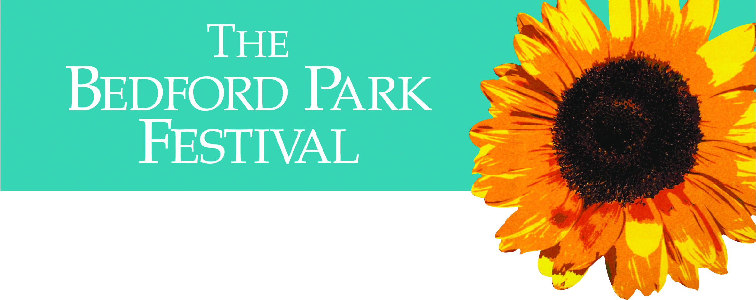
.
There’s no need to trek to the
WEST END
when so many performers are here
IN WEST FOUR
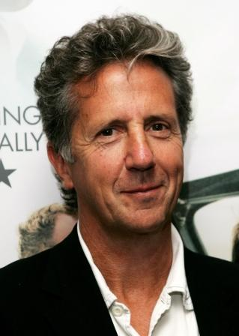
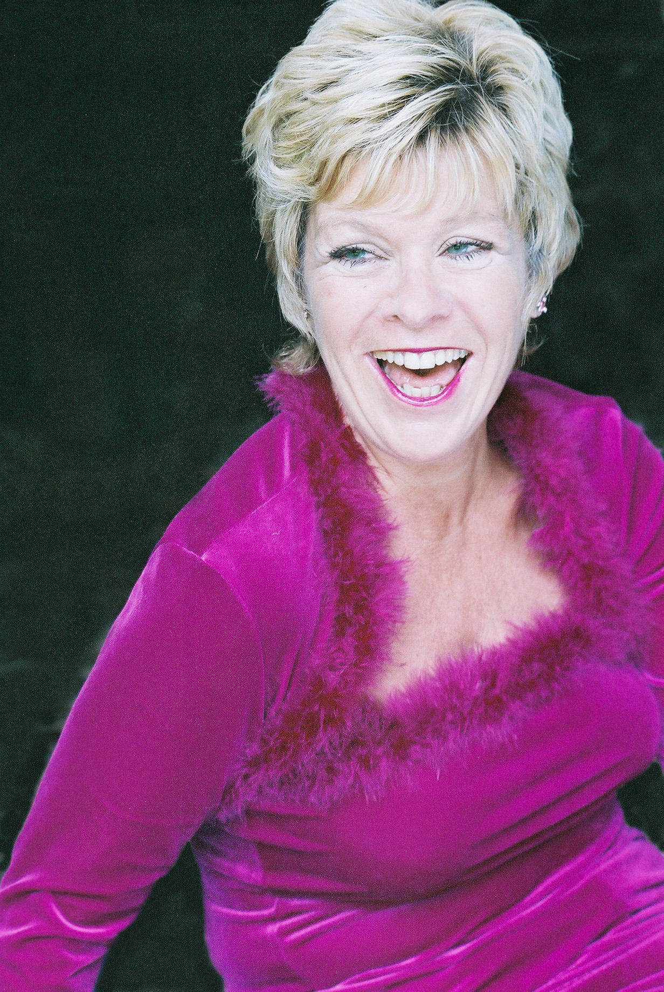
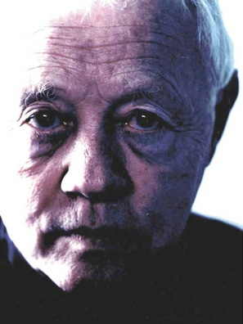
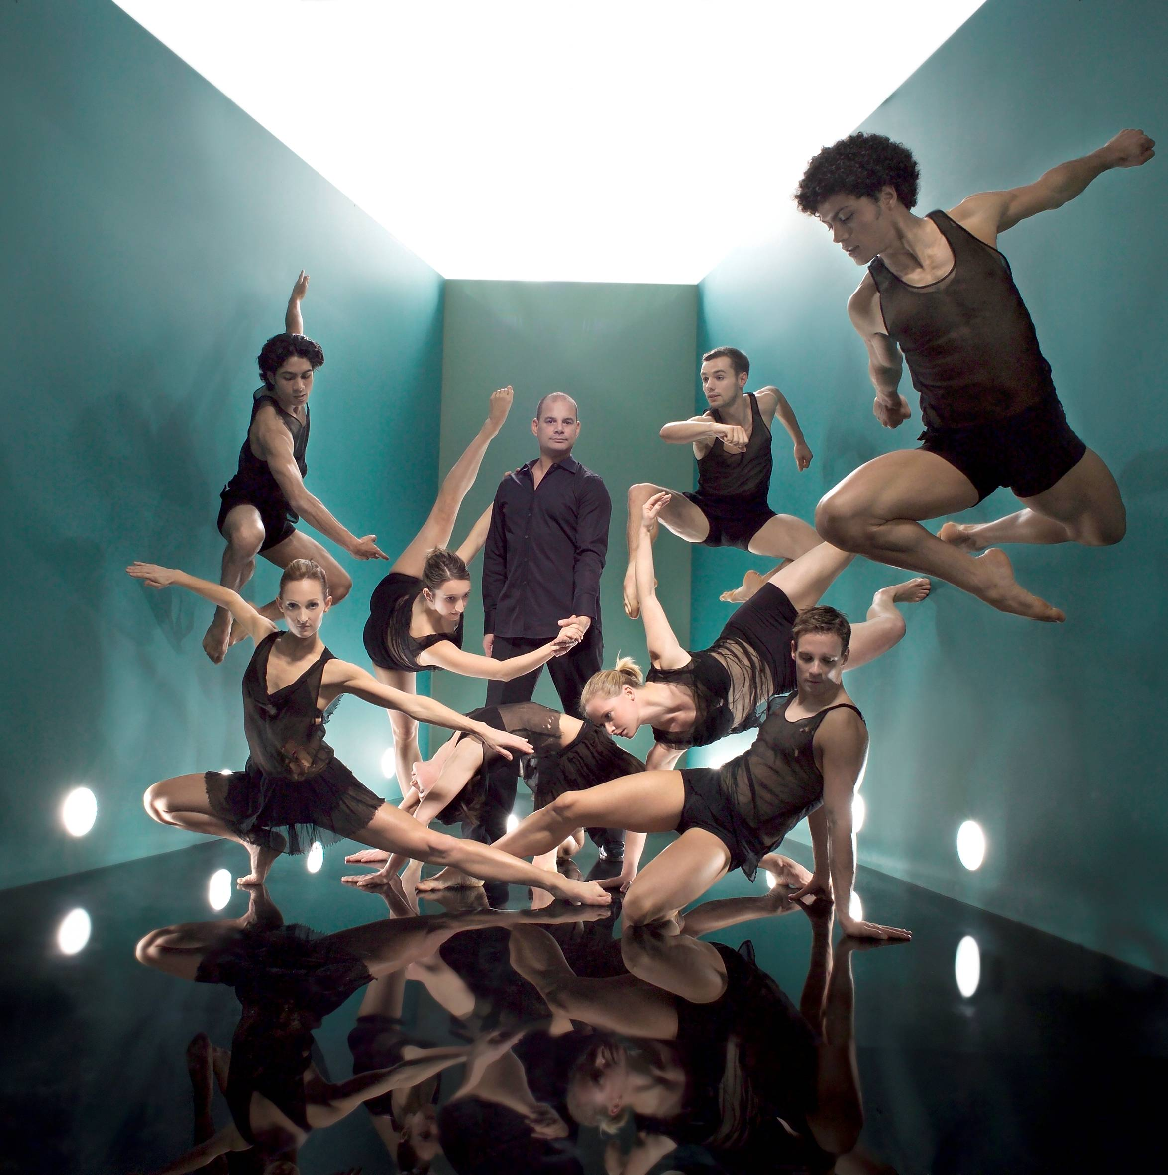
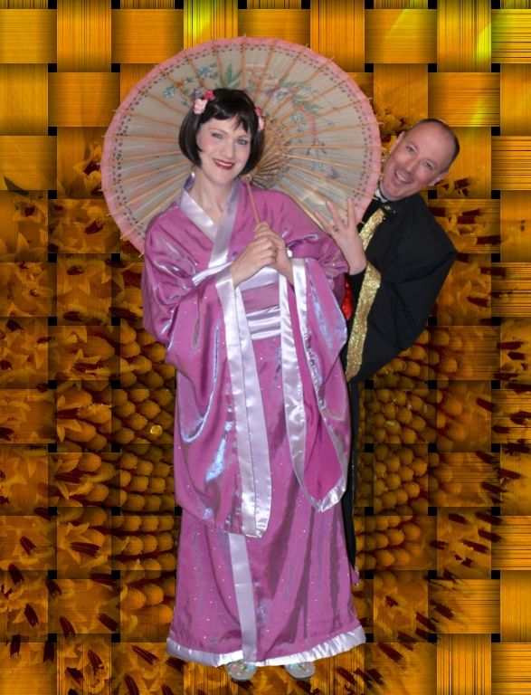
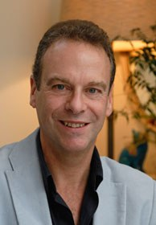
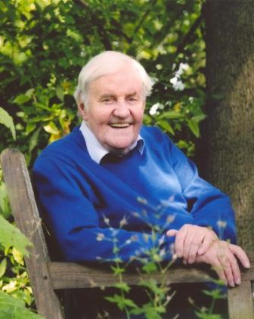

Richard Briers – Green Days – 11am Saturday June 11th
Rosie Ashe (Phantom) – Magic of Musicals - 7.30pm Sunday June 12th
Dudley Sutton (Lovejoy) – Comedy - 8pm Monday June 13th
Rambert Dance Company – Mark Baldwin - 8pm Wednesday June 15th
Punch & Judy – the History – 8pm Thursday June 16th
Opera Novella’s The Mikado – 7.30pm Friday June 17th
Justin Lavender (La Scala, Covent Garden) – Recital - 8pm Saturday 18th
London Tango Quintet – Concert and Supper - 7.30pm Monday June 20th
Blake Morrison on Poetry – 8pm Wednesday June 22nd
Colin Firth, juror for Best Film, BPFShorts.co.uk - 8pm Saturday June 25th
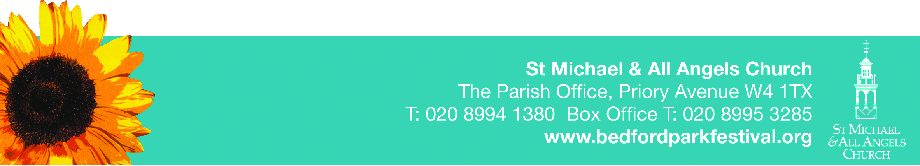
.
Book now: 10% discount for 10 tickets bought in advance, or pay at the door. See leaflets for programme & conditions or www.bedfordparkfestival.org

