The 45th Bedford Park Festival
11th to 26th June 2011
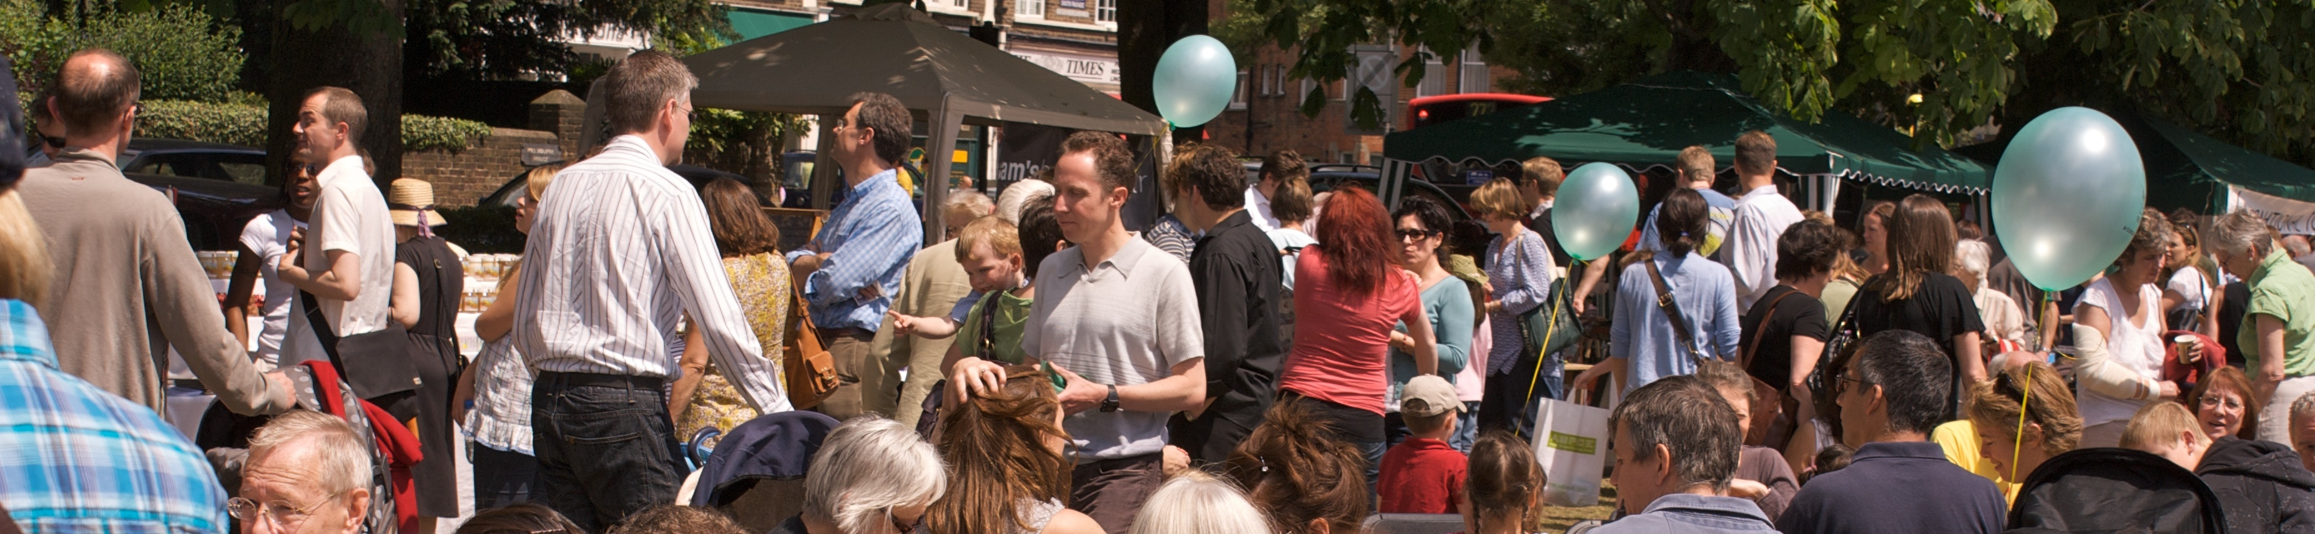
Please join us on Green Days’ most popular stall:
the Mackens Barbecue!
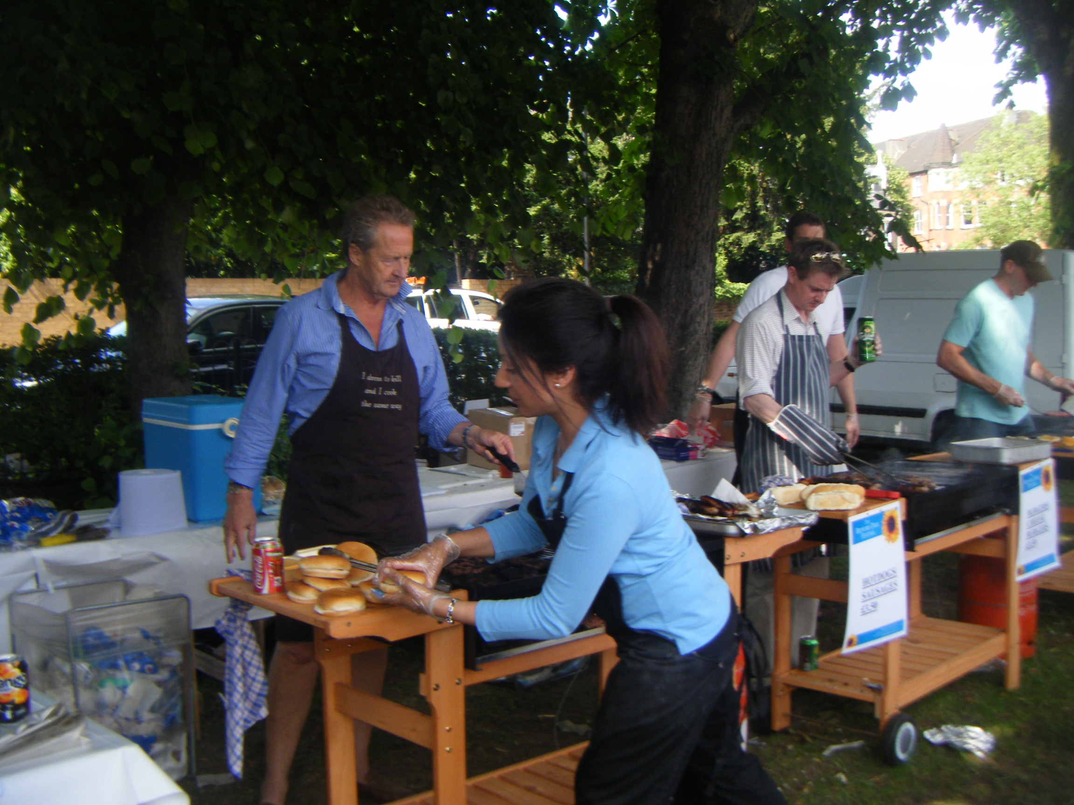

This year we want to run the Barbecue on both days again
and we need more helpers to cook, serve and take money for
the famous Mackens burgers and hotdogs.
To sign up for two-hour stints on Saturday and/or Sunday,
please call Cliff Harper on 07956 300550
or email him at cmpharper@aol.com.
