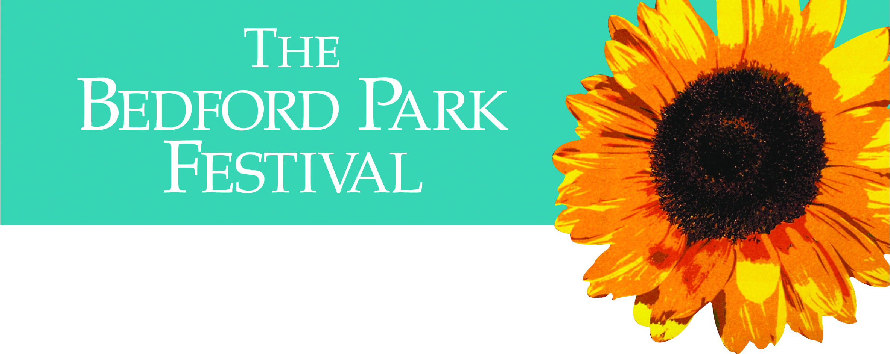

Sponsored by Hamptons
Festival Weekend
at the Tabard Theatre
.
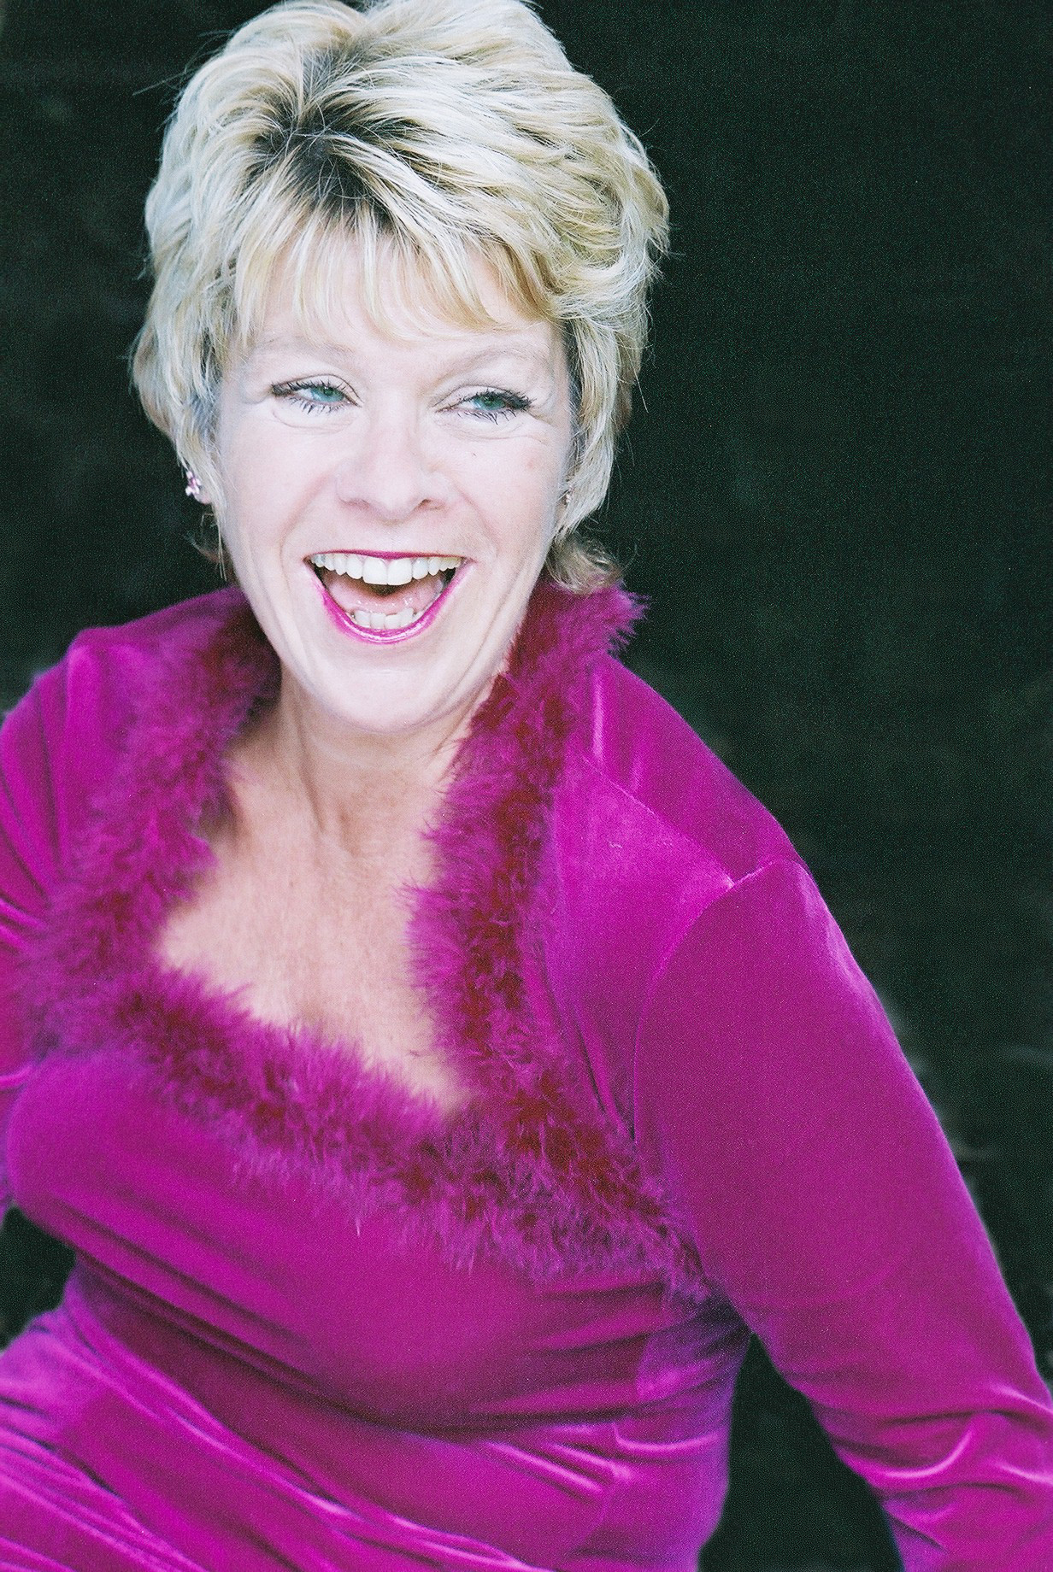
Friday June 10 7.30pm Ruddigore
(Time Out Critics’ Choice) £16/£12
Saturday June 11 7.30pm Ruddigore
Sunday June 12 4.00pm Ruddigore
.
Sunday June 11 7.30pm The Magic of Musicals West End diva Rosie Ashe (Phantom, Les Miserables Mary Poppins) & pianist Jonathan Cohen (Play Away) £12

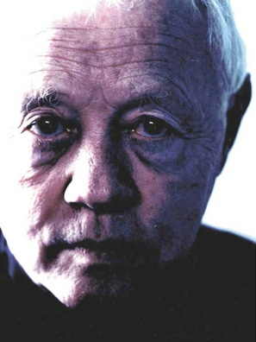
Monday June 13 8pm Old Enough To Know Better
Dudley Sutton (Lovejoy, Skins) – vulgar verse and acute political and personal insights £12
.
Tickets for Ruddigore from: http://www.tabardweb.co.uk/
.
Tickets for 'The Magic of Musicals' and 'Old Enough To Know Better' via Bedford Park Festival box office: 020 8995 3285 and Advance Booking Form in church

. www.bedfordparkfestival.org

