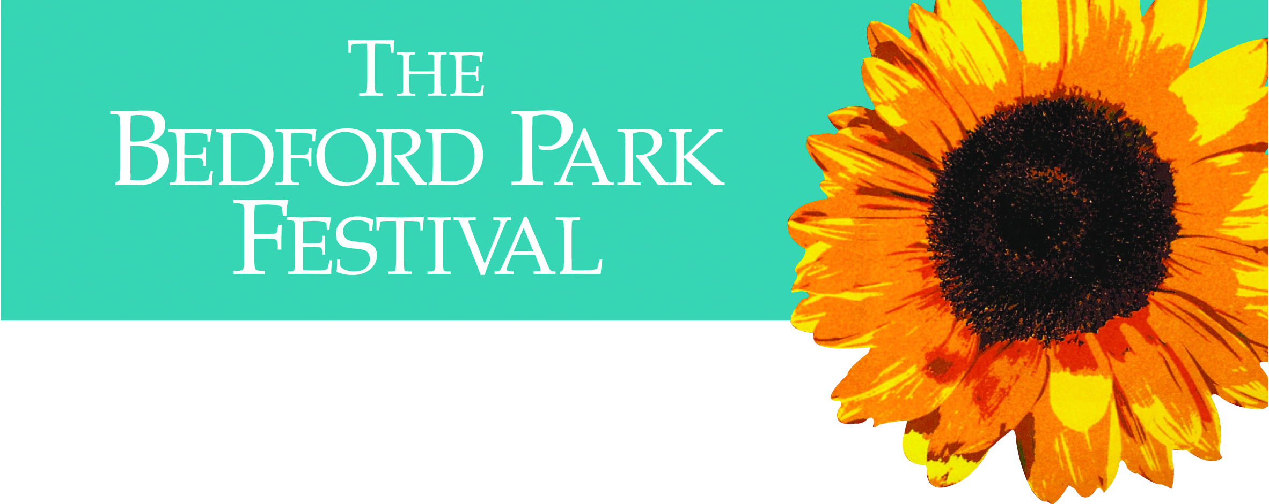
.

Opera Novella Productions presents the
hilarious operetta by Gilbert & Sullivan
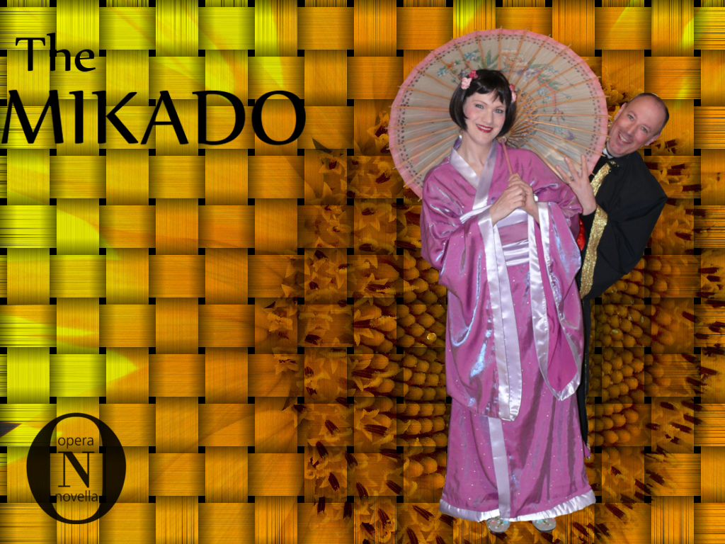
Fun for all
the family*
in this comic
musical
masterpiece!
.
*age 10 upwards
With singers from the D’Oyly Carte, a live orchestra and
Father Kevin Morris, vicar of St Michael & All Angels, as The Mikado.
‘Sally-Ann Shepherdson’s Yum-Yum was exemplary’: The Independent.
.
7 for 7.30pm, Friday June 17th 2011
St Michael & All Angels Church, W4
Tickets £20 (£10 concessions) plus 10% discount for
any 10 Festival tickets booked in advance – see Advance Booking Form for conditions – in church and at www.bedfordparkfestival.org
