Shawls for the Fistula Hospital
(2012 publication)

Thank you for knitting shawls for the patients at the Fistula Hospital in Ethiopia .

Addis Ababa, whilst in the tropics, is 8,000 feet above sea level. This means that at night the temperature drops considerably from the daytime heat. The shawls protect the patients from the heat of the day and the cold nights.

Because of your generosity we are able to supply the main hospital in Addis Ababa and our five satellite hospitals with large quantities, so each patient is given one to take home with them when they are discharged. It is probably the first time in their lives that they have been given something that is really their own, such is their poverty.

Basic guidelines to follow:
Squares knitted in garter stitch (You may crochet if you prefer)
Double knitting wool
Bright colours
You can decide the size squares to knit – or crochet – as long as the finished measurement is approximately 36 inches by 48 inches
THIS IS IMPORTANT

This size wraps nicely around the patients little bodies
No 4mm needles (UK no 8)

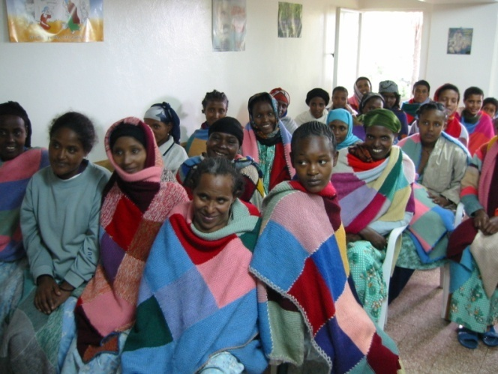
If a thicker ply than DK is used, the finished shawl will be too heavy for the small and often mal-nourished patients to wear.

As the shawls need to be washed frequently, we would like you to add, if possible please, a simple crocheted or a blanket stitch border around the finished edge, this will strengthen them considerably.
Thank you for your cooperation.

If you are unclear on the basic requirements, please call Jean Hadley on 0121 422 8969 or
email jeanhadley1@gmail.com

They should be sent (or taken) in a secure package to :
Hamlin Fistula UK. 4 Parade Buildings, Nimmings Road, Halesowen, West Midlands. B62 9JJ
(If personally taking shawls to the Office, please call 0121 559 3999 in advance to ensure that someone will be there.)

